July 20, 2025 Listening

S2 选择 - 单选/多选

选项 - 短选/长选 - 定位

短选 - 限定

长选 - 选项分析 - 名词/限定词

选项常见的错误特征

1. rather than 选项本身直接被否定
2. 不符合题干的限定信息
3. 选项与音频本身不符

Consume v. 消耗；time-consuming adj. 耗时的；electricity consumption

- v. 消费；consumer n. - customer/client; consumerism n.

- v. 吃/喝；consume （eat/drink） mushrooms

Don’t/never/avoid

The other thing to avoid

Peel v. 剥皮；n. - not necessary to peel

**Animals** - deer/squirrel/giraffe/antelope/leopard/crocodile/chimpanzee - gorilla

- whale/penguin/seal

Toxin n. /toxic; poison/poisonous

**Bright colour**

Some edible mushrooms are bright red.

Dull color

Pale adj.

Do harm to - won’t do you any harm to eat them uncooked

Advice/suggestion/recommendation/a good idea ...

- should/need to

- 立场态度词/褒贬 - 形容词居多

1. Playing fields and wooded areas 并列不出答案

First in the morning - early - NEED TO/ADVICE

B Not only but also

Not just but ... too

App/application

Reference book

Wouldn’t recommend you going alone - B. - you should go with a group

Conservation n. 保护；natural reserve

Preservation n. 保鲜/保存；

Deserve v.

You should never pick all mushrooms in one area - B

Endangered adj. = rare

They will be fine for a couple of days - two days

As soon as possible/asap

Great in so many dishes - stir fries 炒/risottos烩饭/pasta意面

Fry v. - french fries/chips

Stir v. 搅拌；Stew v. 炖；

Oven n. 烤箱；microwave n. 微波炉；

Colour

Advice

You might be **more comfortable** not carrying/keep ... with u around heavy rucksacks - bags/pack/backpack

Fastest-growing communities

Graduates n. - careers - fashion & design - buy new apartments

- to **replace** the small houses - market workers used to live - C

Replace a with b

Undergraduates/postgraduates - master

Resident/dweller/citizen/inhabitant/settler

Craft n. /craftsmen - pottery /china - ceramics/porcelain

Artefact/artifact n. /artisan - vessel 器皿

Original pictures, Jewellery (necklace/bracelets) and ceramics 陶瓷 + local produce 农产品

- arts - sculpture/statue; surface relief features 浮雕

- craft -

Pavement

Entry n. /entrants n.

Contemporary = modern

Inspire v. 1 = encourage/motivate 2 = 给...灵感；inspiration n. = an outfit based on ideas from Music & technology - everyday life - B

Be passionate about fashion

Fibers/fibres 纤维; nylon; plastic - materials - concrete; man-made/artificial

The garments will be judged by experts/fashion designers

- and the winning entries will be modeled at a gala evening.   
Met Gala

Receipt n.

If u can present a receipt from local stores - free = not be charged

Flat rate 固定费率/统一收费

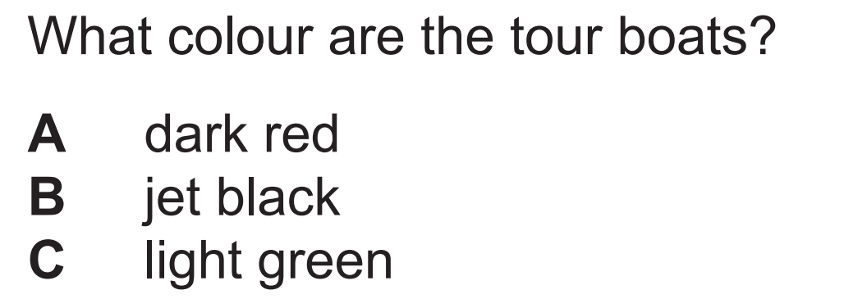

Tour boats - dark red seats; light green exterior

Are - 时态 - used to be; Tourists **can**

1 - ham and tomato sandwiches

2 - cheddar cheese roll

3 - eggs and tuna - fish

S3/S4 学术场景 - 4 学术讲座 /独白 /填空

3 - 学术讨论 2-3人

Nordic countries - + Norway/Finland

Scandinavian - Denmark/Sweden/Iceland

Middle Ages/Medieval; Renaissance

Hardly/went on her own

Woolly mammoth 猛犸象 Asian elephants

- but ... childish adj.

- let’s go with your last suggestion.

确定选项出现顺序

Undergraduate course - be enough for me

Media - journalism 新闻学 - journal 期刊报导/magazine 杂志/TV/radio - broadcast/podcast/newspaper

Press n.

Ad/advert/advertisement

Publicity n. /publicize v.

Publication n. 出版物；出版；

B More creative than translating / rather than

Interpreting / interpret v.

End this term - will be replaced by more specialized courses

Context/background

C more fruitful than A

Try and relate the changes in libraries to external developments - far more people can read than a century ago + local population can speak lots of different languages

- changes in society/ developments in society - **解释说明**

Won’t - Up to date /latest = old; copyright n. 版权；

Physical books

e-book; electronic